STANDARD OPERATING PROCEDURE
Securities Desposits analysis

1. Meaning:

- Security deposits are money kept aside as a guarantee for things like renting a space or equipment. It's like a promise to cover any potential damage or unpaid fees.

- For example, when someone rents a government building or gets a permit, they might have to leave a deposit money as a security deposit.

- Security deposits are money held to protect against potential losses. This could be when customers rent equipment or use services on credit, and the deposit acts as insurance in case they don't pay or there's damage.

2. Purpose:

- Security deposits can represent a significant financial commitment for a company, Auditors need to ensure that these deposits are properly accounted for and recorded.

- It helps ensure that people or businesses have followed the rules or agreements set by the organization before they receive services or benefits.

3. Assertions:

- Existence: Confirm that the security deposits recorded exist and are valid.
  - Example: Physically inspecting the security deposit accounts or documents to ensure they match the recorded amounts.

- Completeness: Ensuring that all security deposits received by the organization are properly recorded.
  - Example: Checking that all security deposits paid by tenants for rental properties are accounted for in the financial records.

- Right and Obligations: Verifying that the organization has the right to hold the security deposits and that any corresponding obligations are properly disclosed.
  - Example: Reviewing lease agreements to ensure they specify the terms and conditions for holding security deposits.

- Valuation: Ensuring that security deposits are recorded at their proper value, typically their original amount.
  - Example: Checking that security deposits are recorded at the amount originally paid by tenants, without any adjustments.

- Presentation and Disclosure: Confirm that security deposits are properly classified and disclosed in the financial statements.
  - Example: Ensuring that security deposits are listed separately on the balance sheet under current liabilities.

4. Step by Step Procedure to test Securities Deposits:

Step 1: The first step is to extract the securities deposits balance from the GL and TB for the year ended, as shown in the screenshot below.
- This information can be obtained from lease agreements, contracts, and accounting records.
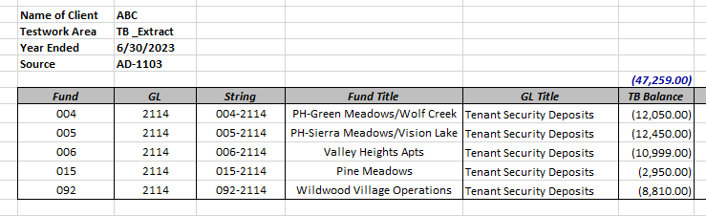
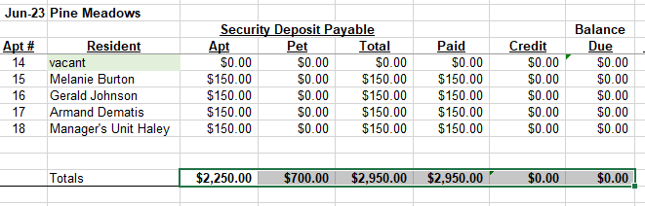
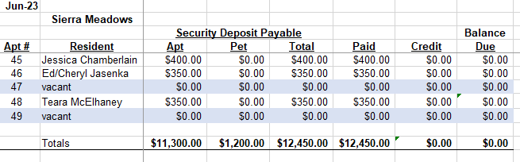
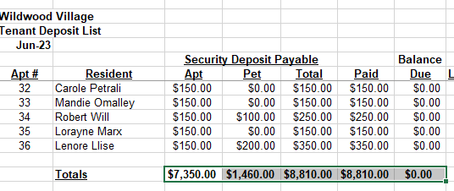
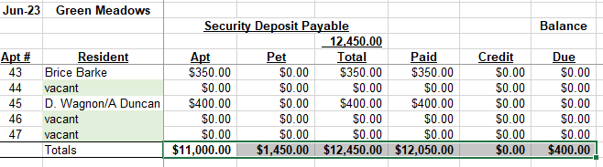
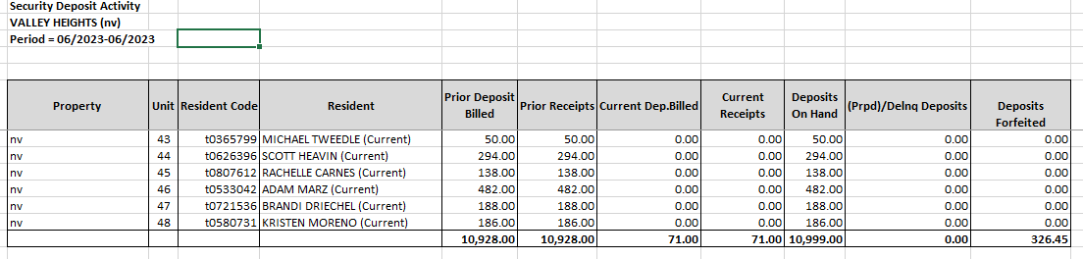

Step 2: Reviewing Securities Deposits Records:
- Obtain supporting documents related to securities deposits, such as deposit receipts or agreements.

- Categorize the security deposits based on their nature, such as rental deposits, utility deposits, or any other type of security deposit held by the company.

- Verify the accuracy of the recorded securities deposits by reconciling them with supporting documents, Investigate any significant variances or discrepancies.

Step 3: Analysis of Security Deposit Aging:
- If applicable, obtain an aging analysis of the security deposits to identify any long-standing or overdue deposits.

- Evaluate the reasons behind any outstanding deposits and assess their recoverability.

Step 4: Review of Security Deposit Terms:
- Review the terms and conditions associated with each security deposit, including the lease agreements or contracts governing the deposits.

- Ensure compliance with legal requirements and accounting standards regarding the treatment of security deposits.

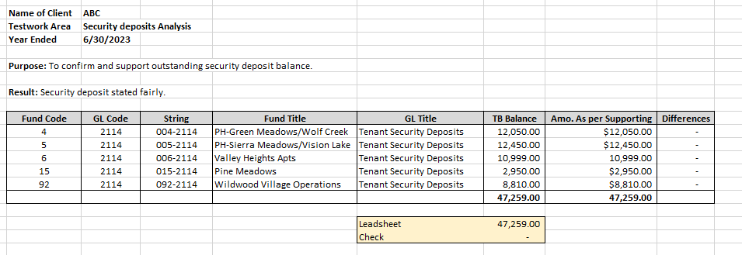
Step 5: Analysis of Interest Accrual:
- If the security deposits accrue interest over time, analyze the accrual of interest income and ensure proper recognition in the financial statements in accordance with accounting principles.

Step 6: Identification of Unclaimed deposits:
- Identify any unclaimed security deposits that may require further investigation or resolution.

- Develop procedures for contacting the respective deposit holders or beneficiaries to facilitate the release or forfeiture of unclaimed deposits.

Audit Program:
It is essential to prepare an audit program tailored to the specific area being audited, such as ALG/NPO-AP-90 for Non-Profit Organizations (NPOs) and governmental entities. Below is an example of an Audit Program for Expenditures/Expenses for Goods/Services and Accounts Payable and Other Liabilities:
Audit Program: ALG/NPO-AP-90

